**Heroku Project Notes**

Project: Deploy a Flask API with a model to serve prediction on Heroku

* Heroku lets you deploy, run and manage applications written in Ruby, Node.js, Java, Python, Clojure, Scala, Go and PHP.
* Dependency mechanisms vary across languages: in Ruby you use a Gemfile, in Python a requirements.txt, in Node.js a package.json, in Java a pom.xml and so on.
* The Heroku platform uses Git as the primary means for deploying applications (there are other ways to transport your source code to Heroku, including via an API).

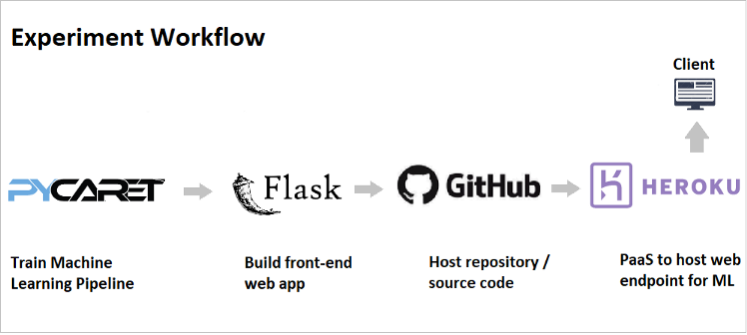

* Train and validate models and develop a machine learning pipeline for deployment.
* Build a basic HTML front-end with an input form for independent variables (age, sex, bmi, children, smoker, region).
* Build a back-end of the web application using a Flask Framework.
* Deploy the web app on Heroku. Once deployed, it will become publicly available and can be accessed via Web URL.

Resources:

<https://devcenter.heroku.com/categories/heroku-architecture>

CLI: <https://devcenter.heroku.com/articles/heroku-cli>

<https://devcenter.heroku.com/articles/using-the-cli>

tutorial : <https://blog.miguelgrinberg.com/post/the-flask-mega-tutorial-part-i-hello-world>

<https://www.youtube.com/watch?v=skc-ZEU9kO8>

<https://www.kdnuggets.com/2020/05/build-deploy-machine-learning-web-app.html>

command line:

curl -i -X POST --data @test.json http://127.0.0.1:5000/predict --header "{"content-type": "application/json", "Accept-Charset": "UTF-8"}"